LP-1 SPOS LA2
Neeti Kurulkar
Design suitable data structures and implement Pass-I and Pass-II of a two-pass macroprocessor. The output of Pass-I (MNT, MDT and intermediate code file without any macro definitions) should be input for Pass-II.

Input Files:
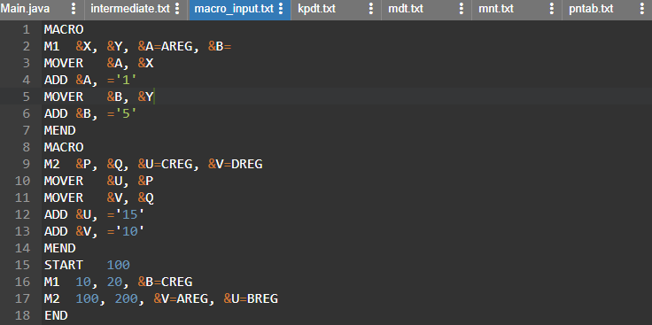

Code:
- Pass 1
import java.io.*;
import java.util.Iterator;
import java.util.LinkedHashMap;

public class Main {

public static void main(String[] args) throws IOException{
BufferedReader br=new BufferedReader(new FileReader("macro_input.txt"));

FileWriter mnt=new FileWriter("mnt.txt");
FileWriter mdt=new FileWriter("mdt.txt");
FileWriter kpdt=new FileWriter("kpdt.txt");
FileWriter pnt=new FileWriter("pntab.txt");
FileWriter ir=new FileWriter("intermediate.txt");
LinkedHashMap<String, Integer> pntab=new LinkedHashMap<>();
String line;
String Macroname = null;
int mdtp=1,kpdtp=0,paramNo=1,pp=0,kp=0,flag=0;
while((line=br.readLine())!=null)
{

String parts[]=line.split("\\s+");
if(parts[0].equalsIgnoreCase("MACRO"))
{
flag=1;
line=br.readLine();
parts=line.split("\\s+");
Macroname=parts[0];
if(parts.length<=1)
{
mnt.write(parts[0]+"\t"+pp+"\t"+kp+"\t"+mdtp+"\t"+(kp==0?kpdtp:(kpdtp+1))+"\n");
continue;
}
for(int i=1;i<parts.length;i++) //processing of parameters
{
parts[i]=parts[i].replaceAll("[&,]", "");
//System.out.println(parts[i]);
if(parts[i].contains("="))
{
++kp;
String keywordParam[]=parts[i].split("=");
pntab.put(keywordParam[0], paramNo++);
if(keywordParam.length==2)
{
kpdt.write(keywordParam[0]+"\t"+keywordParam[1]+"\n");
}
else
{
kpdt.write(keywordParam[0]+"\t-\n");
}
}
else
{
pntab.put(parts[i], paramNo++);
pp++;
}
}
mnt.write(parts[0]+"\t"+pp+"\t"+kp+"\t"+mdtp+"\t"+(kp==0?kpdtp:(kpdtp+1))+"\n");
kpdtp=kpdtp+kp;
//System.out.println("KP="+kp);

}
else if(parts[0].equalsIgnoreCase("MEND"))
{
mdt.write(line+"\n");
flag=kp=pp=0;
mdtp++;
paramNo=1;
pnt.write(Macroname+":\t");
Iterator<String> itr=pntab.keySet().iterator();
while(itr.hasNext())
{
pnt.write(itr.next()+"\t");
}
pnt.write("\n");
pntab.clear();
}
else if(flag==1)
{
for(int i=0;i<parts.length;i++)
{
if(parts[i].contains("&"))
{
parts[i]=parts[i].replaceAll("[&,]", "");
mdt.write("(P,"+pntab.get(parts[i])+")\t");
}
else
{
mdt.write(parts[i]+"\t");
}
}
mdt.write("\n");
mdtp++;
}
else
{
ir.write(line+"\n");
}
}
br.close();
mdt.close();
mnt.close();
ir.close();
pnt.close();
kpdt.close();
System.out.println("Macro Pass1 Processing done. :)");
}

}

Output of Pass1 and Input for Pass2:
- intermediate.txt
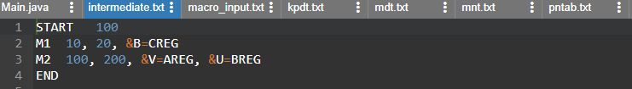

- kpdt.txt
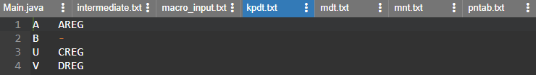

- mdt.txt
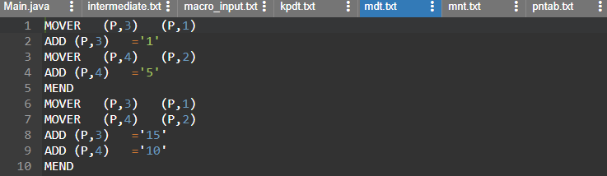

- mnt.txt

- pntab.txt

- Pass 2:
import java.io.*;
import java.util.HashMap;
import java.util.Vector;

class MNTEntry {
String name;
int pp,kp,mdtp,kpdtp;
public MNTEntry(String name, int pp, int kp, int mdtp, int kpdtp) {
super();
this.name = name;
this.pp = pp;
this.kp = kp;
this.mdtp = mdtp;
this.kpdtp = kpdtp;
}
public String getName() {
return name;
}
public void setName(String name) {
this.name = name;
}
public int getPp() {
return pp;
}
public void setPp(int pp) {
this.pp = pp;
}
public int getKp() {
return kp;
}
public void setKp(int kp) {
this.kp = kp;
}
public int getMdtp() {
return mdtp;
}
public void setMdtp(int mdtp) {
this.mdtp = mdtp;
}
public int getKpdtp() {
return kpdtp;
}
public void setKpdtp(int kpdtp) {
this.kpdtp = kpdtp;
}
}

public class Main {

public static void main(String[] args) throws Exception {
BufferedReader irb=new BufferedReader(new FileReader("intermediate.txt"));
BufferedReader mdtb=new BufferedReader(new FileReader("mdt.txt"));
BufferedReader kpdtb=new BufferedReader(new FileReader("kpdt.txt"));
BufferedReader mntb=new BufferedReader(new FileReader("mnt.txt"));

FileWriter fr=new FileWriter("pass2.txt");

HashMap<String, MNTEntry> mnt=new HashMap<>();
HashMap<Integer, String> aptab=new HashMap<>();
HashMap<String,Integer> aptabInverse=new HashMap<>();

Vector<String>mdt=new Vector<String>();
Vector<String>kpdt=new Vector<String>();

int pp,kp,mdtp,kpdtp,paramNo;
String line;
while((line=mdtb.readLine())!=null)
{
mdt.addElement(line);
}
while((line=kpdtb.readLine())!=null)
{
kpdt.addElement(line);
}
while((line=mntb.readLine())!=null)
{
String parts[]=line.split("\\s+");
mnt.put(parts[0], new MNTEntry(parts[0], Integer.parseInt(parts[1]), Integer.parseInt(parts[2]), Integer.parseInt(parts[3]), Integer.parseInt(parts[4])));

}

while((line=irb.readLine())!=null)
{
String []parts=line.split("\\s+");
if(mnt.containsKey(parts[0]))
{
pp=mnt.get(parts[0]).getPp();
kp=mnt.get(parts[0]).getKp();
kpdtp=mnt.get(parts[0]).getKpdtp();
mdtp=mnt.get(parts[0]).getMdtp();
paramNo=1;
for(int i=0;i<pp;i++)
{
parts[paramNo]=parts[paramNo].replace(",", "");
aptab.put(paramNo, parts[paramNo]);
aptabInverse.put(parts[paramNo], paramNo);
paramNo++;
}
int j=kpdtp-1;
for(int i=0;i<kp;i++)
{
String temp[]=kpdt.get(j).split("\t");
aptab.put(paramNo,temp[1]);
aptabInverse.put(temp[0],paramNo);
j++;
paramNo++;
}

for(int i=pp+1;i<parts.length;i++)
{
parts[i]=parts[i].replace(",", "");
String splits[]=parts[i].split("=");
String name=splits[0].replaceAll("&", "");
aptab.put(aptabInverse.get(name),splits[1]);
}
int i=mdtp-1;
while(!mdt.get(i).equalsIgnoreCase("MEND"))
{
String splits[]=mdt.get(i).split("\\s+");
//fr.write("+");
for(int k=0;k<splits.length;k++)
{
if(splits[k].contains("(P,"))
{
splits[k]=splits[k].replaceAll("[^0-9]", "");
String value=aptab.get(Integer.parseInt(splits[k]));
fr.write(value+"\t");
}
else
{
fr.write(splits[k]+"\t");
}
}
fr.write("\n");
i++;
}

aptab.clear();
aptabInverse.clear();
}
else
{
fr.write(line+"\n");
}

}

fr.close();
mntb.close();
mdtb.close();
kpdtb.close();
irb.close();
}
}

Output:
